I/O流

Chapter 1 input/output streams

What is ?
Inputstream:.
Outputstream:

These sources and destinations of byte sequences can be—and often are—files, but they can also be network connections and even blocks of memory. The abstract classes InputStream and OutputStream form the basis for a hierarchy of input/output (I/O) classes

API
java.io.InputStream 1.0

abstract int read()
reads a byte of data and returns the byte read; returns -1 at the end of the input
stream .

int read(byte[] buf)
reads into an array of bytes and returns the actual number of bytes read, or -1 at the
end of the input stream; this method reads at most b.length bytes.

int read(byte[] buf,int off,int len)
buf: into this byte[]

long skip(long n)
skips n bytes in the input stream, returns the actual number of bytes skipped (which
may be less than n if the end of the input stream was encountered).

int available()
returns the number of bytes available, without blocking (recall that blocking means
that the current thread loses its turn).
int bytesAvailable = in.available();
if (bytesAvailable > 0)
{
byte[] data = new byte[bytesAvailable];
in.read(data);
}

void close()
Just close the inputstream,without flushing.

void mark(int readlimit)

void reset()

boolean markSupported()

java.io.OutputStream 1.0

abstract void write(int n)
writes a byte of data.

void write(byte[] b)
writes from byte[] b into outputstream

void close()
flushes and closes the output stream.

void flush()

e.g:
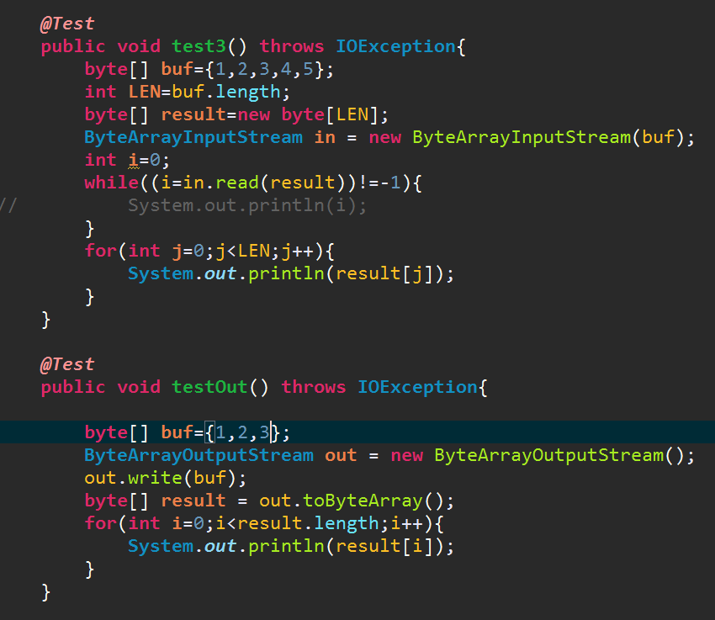

The Complete Stream Zoo
Let’s divide the animals in the input/output stream zoo by how they are used. There are
separate hierarchies for classes that process bytes and characters.

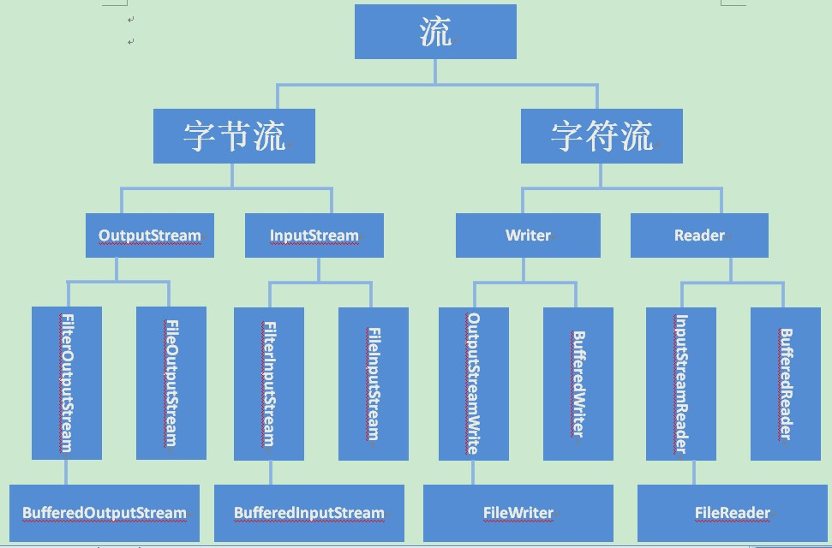

API

java.io.Closeable 5.0 (an interface has only one method)
void close()

java.io.Flushable 5.0 (an interface has only one method)
void flush()

java.lang.Readable 5.0
int read(CharBuffer cb)

java.lang.Appendable 5.0
()

Appendable append(CharSequence cs)

java.lang.CharSequence 1.4

The CharSequence interface describes basic properties of a sequence of char values. It is implemented by String, CharBuffer, StringBuilder, and StringBuffer.

char charAt(int index)
returns the code unit at the given index.

int length()

CharSequence subSequence(int startIndex, int endIndex)
returns a CharSequence consisting of the code units stored from index startIndex to endIndex - 1.

String toString()

Combining Input/Output Stream Filters
You can add multiple capabilities by nesting the filters.
DataInputStream din = new DataInputStream(
new BufferedInputStream(
new FileInputStream("employee.dat")));

Notice that we put the DataInputStream last in the chain of constructors because we want to use the DataInputStream methods, and we want them to use the buffered read method.

ZipInputStream zin = new ZipInputStream(new FileInputStream("employee.zip"));
DataInputStream din = new DataInputStream(zin);

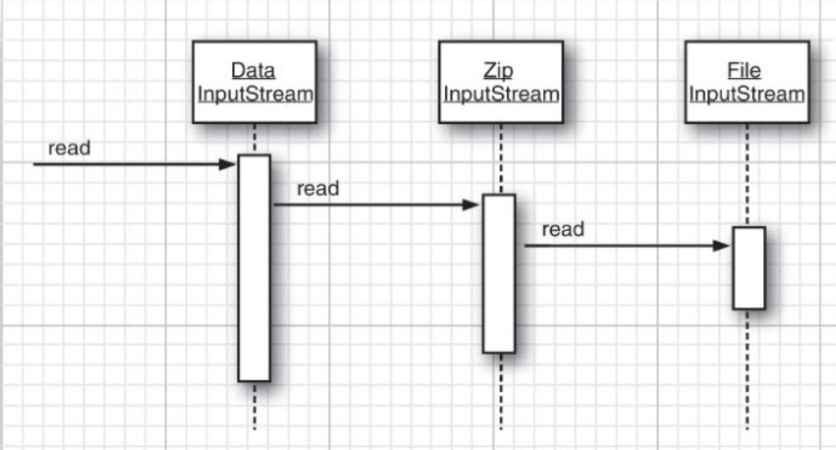

API

java.io.FileInputStream 1.0

FileInputStream(String name)
creates a new file input stream using the file whose path name is specified by the name string or the file object. (The File class is described at the end of this chapter.) Path names that are not absolute are resolved relative to the working directory that was set when the VM started.

FileOutputStream(String name)
FileOutputStream(String name, boolean append)
FileOutputStream(File file)
FileOutputStream(File file, boolean append)
creates a new file output stream specified by the name string or the file object. (The File class is described at the end of this chapter.) If the append parameter is true, an existing file with the same name will not be deleted and data will be added at the end of the file. Otherwise, this method deletes any existing file with the same name.

java.io.BufferedInputStream 1.0
BufferedInputStream(InputStream in)

Chapter 2 Text Input and Output

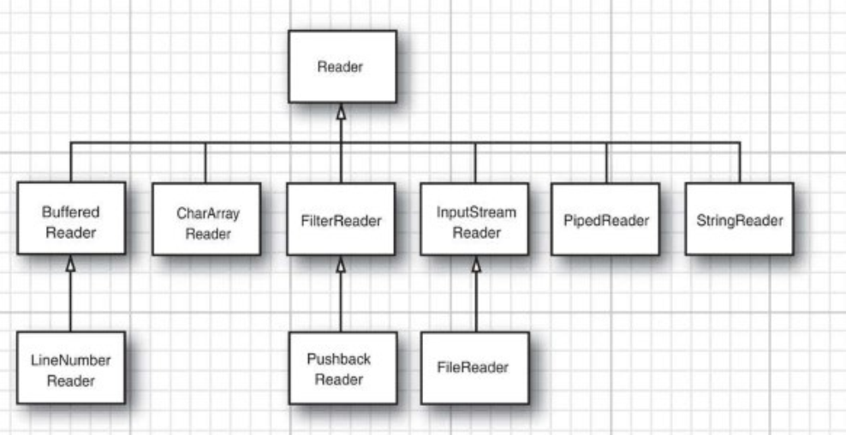

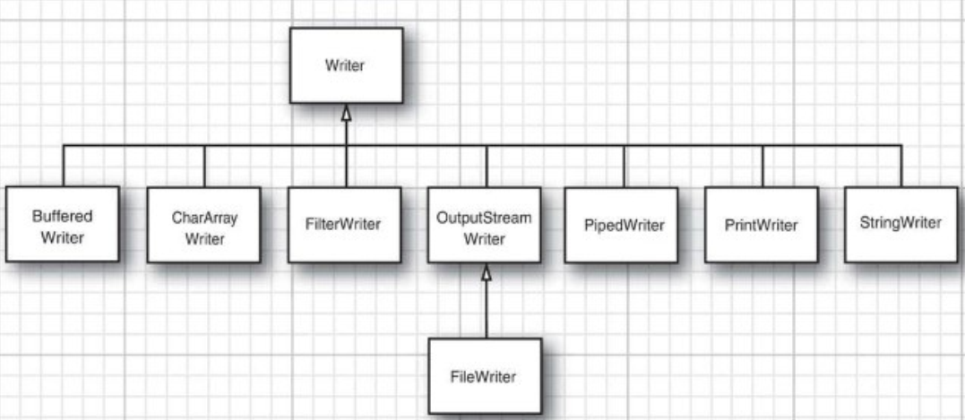

OutputStreamWriter: .
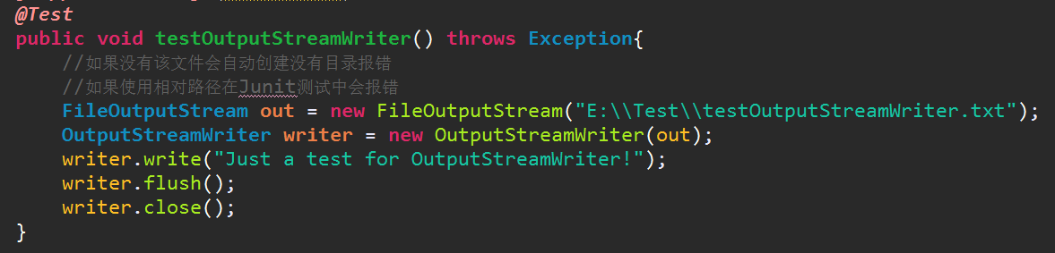
InputStreamReader:
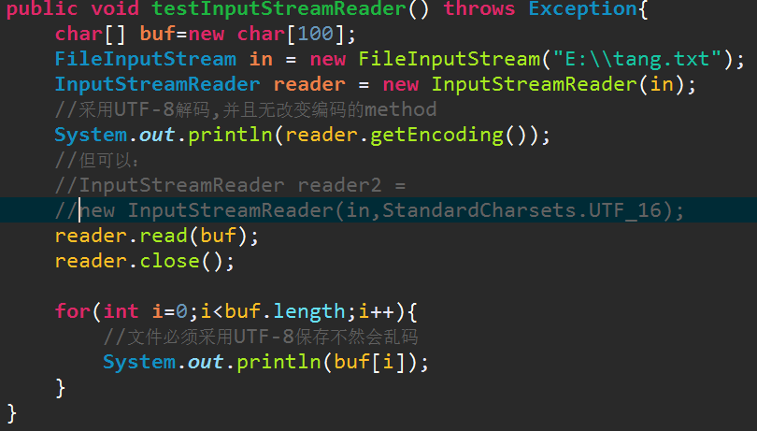
Remeber they are writers and readers,so their method operate Unicode
!
Reader in = new InputStreamReader(new FileInputStream("data.txt"),
StandardCharsets.UTF_8);

How to Write Text Output
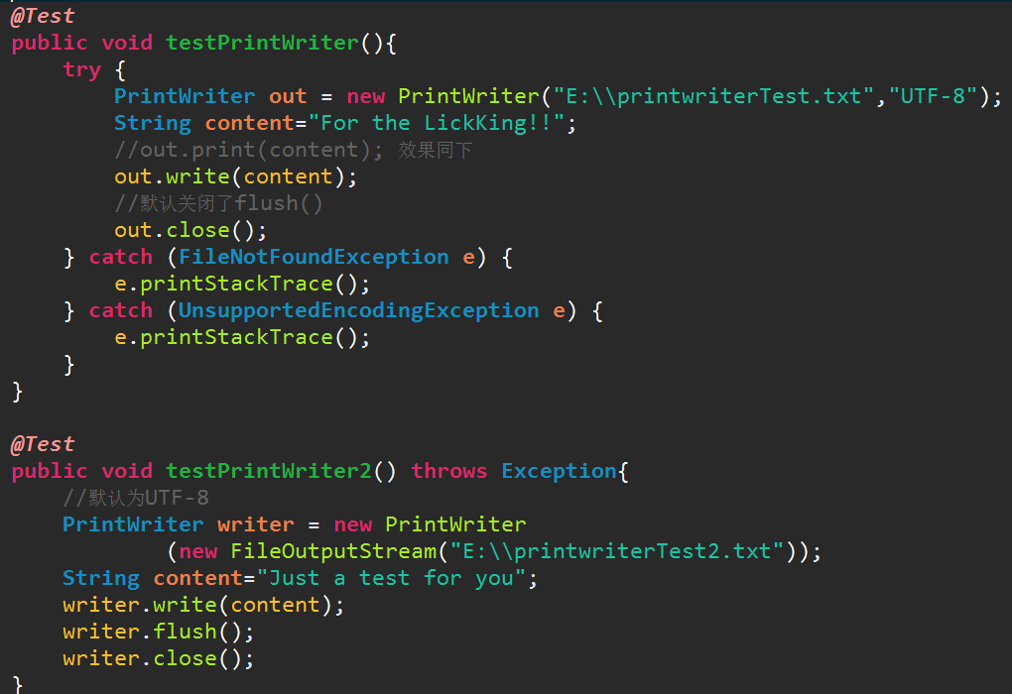

API

utputStream
ut

PrintWriter(Writer out,boolean autoFlush)

.

How to Read Text Input

补充Scanner:
java.util.Scanner是Java5的新特征，主要功能是简化文本扫描。这个类最实用的地方表现在获取控制台输入，其他的功能都很鸡肋，尽管Java API文档中列举了大量的API方法，但是都不怎么地。
一、扫描控制台输入
这个例子是常常会用到，但是如果没有Scanner，你写写就知道多难受了。
当通过new Scanner(System.in)创建一个Scanner，控制台会一直等待输入，直到敲回车键结束，把所输入的内容传给Scanner，作为扫描对象。如果要获取输入的内容，则只需要调用Scanner的nextLine()方法即可。
/**
* 扫描控制台输入
*
* @author leizhimin 2009-7-24 11:24:47
*/
public class TestScanner {
public static void main(String[] args) {
Scanner s = new Scanner(System.in);
System.out.println("请输入字符串：");
while (true) {
String line = s.nextLine();
if (line.equals("exit")) break;
System.out.println(">>>" + line);
}
}
}
请输入字符串：
234
>>>234
wer
>>>wer
bye
>>>bye
exit
Process finished with exit code 0
二、如果说Scanner使用简便，不如说Scanner的构造器支持多种方式，构建Scanner的对象很方便。
可以从字符串（Readable）、输入流、文件等等来直接构建Scanner对象，有了Scanner了，就可以逐段（根据正则分隔式）来扫描整个文本，并对扫描后的结果做想要的处理。
三、Scanner默认使用空格作为分割符来分隔文本，但允许你指定新的分隔符
使用默认的空格分隔符：
public static void main(String[] args) throws FileNotFoundException {
Scanner s = new Scanner("123 asdf sd 45 789 sdf asdfl,sdf.sdfl,asdf ......asdfkl las");
// s.useDelimiter(" |,|\\.");
while (s.hasNext()) {
System.out.println(s.next());
}
}
123
asdf
sd
45
789
sdf
asdfl,sdf.sdfl,asdf
......asdfkl
las
Process finished with exit code 0
将注释行去掉，使用空格或逗号或点号作为分隔符，输出结果如下：
123
asdf
sd
45
789
sdf
asdfl
sdf
sdfl
asdf
asdfkl
las
Process finished with exit code 0
四、一大堆API函数，实用的没几个
（很多API，注释很让人迷惑，几乎毫无用处，这个类就这样被糟蹋了，启了很不错的名字，实际上做的全是龌龊事）
下面这几个相对实用：
delimiter()
返回此 Scanner 当前正在用于匹配分隔符的 Pattern。
hasNext()
判断扫描器中当前扫描位置后是否还存在下一段。（原APIDoc的注释很扯淡）
hasNextLine()
如果在此扫描器的输入中存在另一行，则返回 true。
next()
查找并返回来自此扫描器的下一个完整标记。
nextLine()
此扫描器执行当前行，并返回跳过的输入信息。
五、逐行扫描文件，并逐行输出
看不到价值的扫描过程
public static void main(String[] args) throws FileNotFoundException {
InputStream in = new FileInputStream(new File("C:\\AutoSubmit.java"));
Scanner s = new Scanner(in);
while(s.hasNextLine()){
System.out.println(s.nextLine());
}
}
package own;
import java.io.BufferedReader;
import java.io.BufferedWriter;
import java.io.InputStream;
import java.io.InputStreamReader;
import java.io.OutputStreamWriter;
import java.net.HttpURLConnection;
import java.net.ProtocolException;
import java.net.URL;
import com.verisign.uuid.UUID;
/**
* @author wangpeng
*
*/
public class AutoSubmit {
/**
* @param args
* @throws Exception
*/
public static void main(String[] args) throws Exception {
...在此省略N行
Process finished with exit code 0

Nowadays, the BufferedReader class also has a lines method that yields a Stream<String>.However, unlike a Scanner, a BufferedReader has no methods for reading numbers.

Character Encodings
encode:Charaters to bytes
decode:Bytes to Charaters

difference between Unicode & UTF-8

作者：陆思充
链接：https://www.zhihu.com/question/23374078/answer/77929088
来源：知乎
著作权归作者所有。商业转载请联系作者获得授权，非商业转载请注明出处。
先捋一捋ASCII编码和Unicode编码的区别：ASCII编码是1个字节，而Unicode编码通常是2个字节。
字母A用ASCII编码是十进制的65，二进制的01000001；
字符0用ASCII编码是十进制的48，二进制的00110000，注意字符'0'和整数0是不同的；
汉字中已经超出了ASCII编码的范围，用Unicode编码是十进制的20013，二进制的0100111000101101。
你可以猜测，如果把ASCII编码的A用Unicode编码，只需要在前面补0就可以，因此，A的Unicode编码是0000000001000001。
新的问题又出现了：如果统一成Unicode编码，乱码问题从此消失了。但是，如果你写的文本基本上全部是英文的话，用Unicode编码比ASCII编码需要多一倍的存储空间，在存储和传输上就十分不划算。
所以，本着节约的精神，又出现了把Unicode编码转化为“可变长编码”的UTF-8编码。UTF-8编码把一个Unicode字符根据不同的数字大小编码成1-6个字节，常用的英文字母被编码成1个字节，汉字通常是3个字节，只有很生僻的字符才会被编码成4-6个字节。如果你要传输的文本包含大量英文字符，用UTF-8编码就能节省空间：
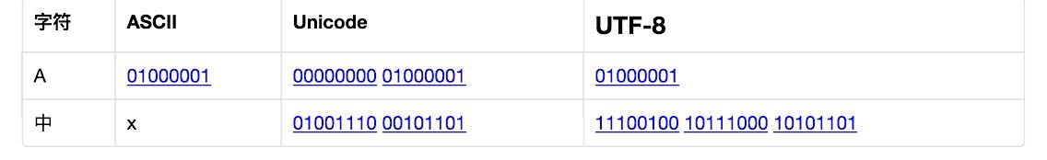
从上面的表格还可以发现，UTF-8编码有一个额外的好处，就是ASCII编码实际上可以被看成是UTF-8编码的一部分，所以，大量只支持ASCII编码的历史遗留软件可以在UTF-8编码下继续工作。

The StandardCharsets class has static variables of type Charset for the character encodings that every Java virtual machine must support:
StandardCharsets.UTF_8
StandardCharsets.UTF_16
StandardCharsets.UTF_16BE
StandardCharsets.UTF_16LE
StandardCharsets.ISO_8859_1
StandardCharsets.US_ASCII

Chapter 3 Reading and Writing Binary Data

The DataInput and DataOutput interfaces
API

ZipInputStream & ZipOutputStream(x)

Chapter 4 Saving and Loading Serializable Objects (x)

Chapter 5 Working with Files

Path

A path does not have to correspond to a file that actually exists.
API

java.nio.file.Paths 7
static Path get(String first, String... more)
makes a path by joining the given strings.
java.nio.file.Path 7
Path resolve(Path other)
Path resolve(String other)
if other is absolute, returns other; otherwise, returns the path obtained by joining this and other.
Path resolveSibling(Path other)
Path resolveSibling(String other)
if other is absolute, returns other; otherwise, returns the path obtained by joining the parent of this and other.
Path relativize(Path other)
returns the relative path that, when resolved with this, yields other.
Path normalize()
removes redundant path elements such as . and ..
Path toAbsolutePath()
returns an absolute path that is equivalent to this path.
Path getParent()
returns the parent, or null if this path has no parent.
Path getFileName()
returns the last component of this path, or null if this path has no components.
Path getRoot()
returns the root component of this path, or null if this path has no root components.
toFile()
makes a File from this path
.
java.io.File 1.0
Path toPath()7
makes a Path from this file

Reading and Writing File

java.nio.file.Files 7
static byte[] readAllBytes(Path path)
static List<String> readAllLines(Path path, Charset charset)
reads the contents of a file.
static Path write(Path path, byte[] contents, OpenOption... options)
static Path write(Path path, Iterable<? extends CharSequence> contents,
OpenOption options)
writes the given contents to a file and returns path.

static InputStream newInputStream(Path path, OpenOption... options)
static OutputStream newOutputStream(Path path, OpenOption... options)
static BufferedReader newBufferedReader(Path path, Charset charset)
static BufferedWriter newBufferedWriter(Path path, Charset charset,
OpenOption... options)

java.nio.file.Files 7
• static Path createFile(Path path, FileAttribute<?>... attrs)
• static Path createDirectory(Path path, FileAttribute<?>... attrs)
• static Path createDirectories(Path path, FileAttribute<?>... attrs)
creates a file or directory. The createDirectories method creates any intermediate
directories as well.
• static Path createTempFile(String prefix, String suffix, FileAttribute<?>...
attrs)
• static Path createTempFile(Path parentDir, String prefix, String suffix,
FileAttribute<?>... attrs)
• static Path createTempDirectory(String prefix, FileAttribute<?>... attrs)
• static Path createTempDirectory(Path parentDir, String prefix,
FileAttribute<?>... attrs)
creates a temporary file or directory, in a location suitable for temporary files or in
the given parent directory. Returns the path to the created file or directory

Copying, Moving, and Deleting Files

java.nio.file.Files 7
• static Path copy(Path from, Path to, CopyOption... options)
• static Path move(Path from, Path to, CopyOption... options)
copies or moves from to the given target location and returns to.
• static long copy(InputStream from, Path to, CopyOption... options)
• static long copy(Path from, OutputStream to, CopyOption... options)
copies from an input stream to a file, or from a file to an output stream, returning the
number of bytes copied.
• static void delete(Path path)
• static boolean deleteIfExists(Path path)

Getting File Information

java.nio.file.Files 7
• static boolean exists(Path path)
• static boolean isHidden(Path path)
• static boolean isReadable(Path path)
• static boolean isWritable(Path path)
• static boolean isExecutable(Path path)
• static boolean isRegularFile(Path path)
• static boolean isDirectory(Path path)
• static boolean isSymbolicLink(Path path)
checks for the given property of the file given by the path.
• static long size(Path path)
gets the size of the file in bytes.
• A readAttributes(Path path, Class<A> type, LinkOption... options)
reads the file attributes of type A.
java.nio.file.attribute.BasicFileAttributes 7
• FileTime creationTime()
• FileTime lastAccessTime()
• FileTime lastModifiedTime()
• boolean isRegularFile()
• boolean isDirectory()
• boolean isSymbolicLink()
• long size()
• Object fileKey()
gets the requested attribute.

Visiting Directory Entries

